VGA Demo
Yue (Julien) Niu (yueniu@usc.edu)

- VGA on NEXYS4

VGA is a display interface which can display any pre-defined color onto monitors. In NEXYS4, there are 14 signals from FPGA adjusting the display. For each color component (R, G, B), 4-bit signals will be generated from FPGA. Besides, two standard sync signals (Horizontal Sync, Vertical Sync) are needed to scan each pixel.

Design with VGA is to generate these 14 signals (12 color signals, 2 sync signal) using FPGA so that the corresponding colors will be projected onto each pixel when timing is correct!

We will be using 640x480 monitor to display the content. What we need do is to output a pre-defined color ([3:0] vgaR, [3:0] vgaG, [3:0] vgaB) when scanning each pixel. The scanning process is controlled only by two signals (hSync, vSync). A very simplified version is shown as below:
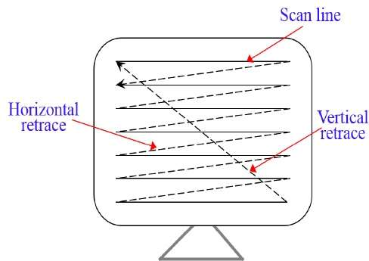

hSync controls the horizontal scanning position, while vSync control the vertical scanning position. Therefore, (hSync, vSync) can define the display area. You can relate it to SSD display, in which Anode signal controls the scanning, and {Ca, Cb, Cc, Cd, Ce, Cf, Cg} controls the display content.

However, to correctly display the content, delicate timing control is necessary. Sync signal (hSync, vSync) needs to be valid during the right time slot. At the beginning of each row or column, we need to wait certain time (T_{fp}) before outputting sync signals. Similarly, we also need to wait T_{pw} before outputting color signal, and disable display before T_{bp} to the end.
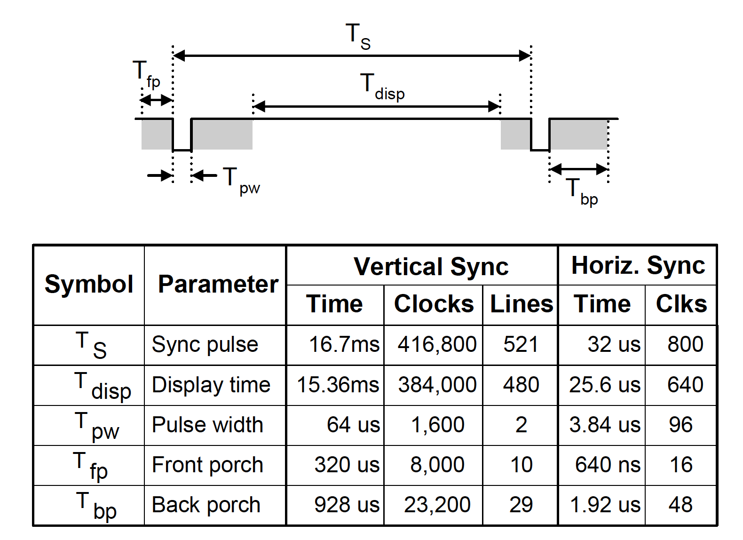

Above is a simplified guide for you to quickly get familiar with VGA interface. A comprehensive VGA manual can be found in NEXYS4 user guide.

- VGA Demo

This VGA demo is aimed to give you some initial idea of how generate blocks with different color and how to move these blocks.

Code hierarchy is shown as below:

vga_top
|
|----display_controller: generate Sync (hSync, vSync) signal and define display area.
|
|----vga_bitchange: generate color (vgaR, vgaG, vgaB) signal.
|
|----counter: user-defined logic.

display_controller and vga_bitchange are the most important two modules. In display_controller module, it defines how to generate the sync signal; when to enable/disable sync signal. The timing control exactly follows VGA display specification in NEXYS4.

vga_bitchange module acts as the center role to deliver video data. In this module, you can define the size/color of boxes; how to move these boxes; how to use buttons/time counter to control these boxes. You can even define more complex shapes. Some previous groups even read pictures from memory and output the data to the monitor.

counter module is related to you design. For example, if you plan to implement a game, counter might serve as a scoreboard. You can also display the score to SSDs.

This demo code just gives a simple framework of designing with VGA interface. You do NOT have to exactly follow the hierarchy. Actually, we encourage you to go beyond the demo code, rather than tweak it. Most groups in previous semesters designed super interesting and nontrivial game interfaces using VGA interface. You can also do it!

- Brainstorms

- If you want to do VGA related project, there are some interesting things you can do. For example, a simplified flappy bird is definitely possible with things you have learned so far; another interesting idea (a little more challenging) is to design the snake game; if you know how to display small pictures, you can even do more complex thing, like Donkey Kong.

- If you do not have VGA in your hand (we understand some situation you might face), you can instead do some simulation project. For example, you can implement some algorithms (sorting; matrix multiplication; etc) using Verilog, then write you own testbench code to check correctness and measure the performance (#clock cycles needed).

